ECO (indoor analog clock) for MOBALINE

Hint: Refer to leaflet for more detailed information.

Additional parts and options:
ECO.30.SET: wall and ceiling kit for 30cm double face clock
ECO.40.SET: wall and ceiling kit for 40cm or double face clock

The indoor analog ECO slave clock, with hour & minute black hands and optional red second hand, is available in single or double face execution.
This is a round style clock, with a low-profile housing made of high quality white ABS plastic, fitted with a transparent acrylic protective cover. The clock is available in dial’s diameters of 30 and 40 cm with markers printed in black and optionally black numerals for hours.

Movement with MOBALine interface:
The movement is synchronised and powered by Mobaline low voltage, noise immune modulated protocol over a simple 2-wires cable. The movement embedded microprocessor performs protocol analysis and diagnostics as well as the mechanical check of hand's position. In addition it has the capability to decode time zones protocol’s information in order to be used for world time clock realisation.
The Mobaline bus allows versatile installation topology, clocks can be wired in serial, parallel or mixed serial-parallel configuration. Every single branch, starting from the master clock, can be up to 1600 meters long.

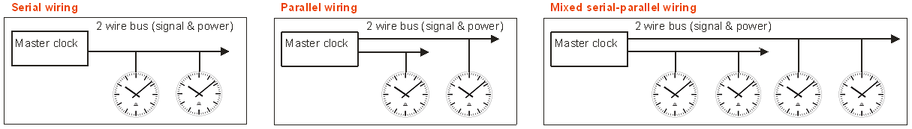
ORDER REFERENCE:

ECO. 1 . 2 . 3 (see position description below)

- synchronization and hands specification:
  - Mobaline hour and minute hands: M00
  - Mobaline hour, minute and second hands: M01

- dial diameter size
  - 30 cm: 30
  - 40 cm: 40

- numeral type
  - markers only: 200
  - markers and numbers: 210
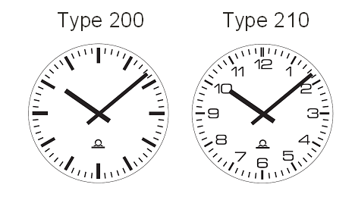

ECO (indoor analog clock) for NTP

Hint: Refer to leaflet for more detailed information.

Additional parts and options:
ECO.30.SET: wall and ceiling kit for 30cm double face clock
ECO.40.SET: wall and ceiling kit for 40cm or double face clock
MOBA-NMS:configuration, management and supervision software

The indoor analog ECO slave clock, with hour & minute black hands and optional red second hand, is available in single or double face execution.
This is a round style clock, with a low-profile housing made of high quality white ABS plastic, fitted with a transparent acrylic protective cover. The clock is available in dial’s diameters of 30 and 40 cm with markers printed in black and optionally black numerals for hours.

NTP- synchronised movement with 10/100 Mbit/s (baseT-8P8C) Ethernet interface:
The clock embeds a microprocessor based movement performing communication analysis and diagnostics as well as the mechanical check of hand's position.
The movement synchronised by NTP protocol is able to sustain unicast (with up to 4 NTP referenced servers) and multicats communication modes. In addition it has the capability to decode NTP frame containing time zones information in order to be used for world time clock realisation.
The configuration, management and supervision of more than 1000 movements can be done through network remote access by MOBA-NMS software which provides a friendly user graphic interface under windows or LINUX OS environment.
The movement configuration can also be fully and autonomously achieved by DHCP protocol under server management. The movement supports also the SNMP protocol and is able to manage alarm and alive messages straps.
Powering is performed by PoE (power over Ethernet) via standard RJ-45 Ethernet interface.

ORDER REFERENCE:

ECO. 1 . 2 . 3 (see position description below)

- synchronization and hands specification:
  - Ethernet – NTP / power - PoE / hour and minute hands: N20
  - Ethernet – NTP / power - PoE / hour, minute and second hands: N21
  - Ethernet – NTP / power - PoE / hour and minute hands (low noise): N22
  - Ethernet – NTP / power - PoE / hour, minute and second hands (low noise): N23

- dial diameter size
  - 30 cm: 30
  - 40 cm: 40
- numeral type
  - markers only: 200
  - markers and numbers: 210

ECO (indoor analog clock) for Wireless

Hint: Refer to leaflet for more detailed information.

Additional parts and options:
ECO.30.SET: wall and ceiling kit for 30cm double face clock
WTD 868-T: Wireless Time Distribution Transmitter
WTD 868-T MPS: external power supply for WTD transmitter
WTD 868-RS: Wireless Time Distribution Test Receiver
WTD Repeater: Wireless Time Distribution Repeater

The indoor analog ECO slave clock, with hour & minute black hands and optional red second hand, is available in single or double face execution.
This is a round style clock, with a low-profile housing made of high quality white ABS plastic, fitted with a transparent acrylic protective cover. The clock is available in dial’s diameters of 25 and 30 cm with markers printed in black and optionally black numerals for hours.

Movement with Wireless receiver (WTD):
The movement is synchronised by a wireless protocol modulated in the 868 MHz frequency band in accordance with AFNOR NFS code 87500. In addition it has the capability to decode time zones protocol’s information in order to be used for world time clock realisation.
The movement embedded microprocessor performs communication analysis and diagnostics as well as the mechanical check of hand's position.

The movements can be powered with two 1.5 V batteries (IEC LR6 type) or through mains power supply (110 - 240 VAC) with optional built-in add-on converter.

ORDER REFERENCE:

ECO. 1 . 2 . 3 (see position description below)

- synchronization and hands specification:
  - Wireless hour and minute hands: R75
  - Wireless hours, minute and second hands: R76

- dial diameter size
  - 30 cm: 30
  - 40 cm: 40
- numeral type
  - markers only: 200
  - markers and numbers: 210

