**METROLINE (outdoor analog clock) for MOBALINE**

Hint: Refer to leaflet for more detailed information.

Additional parts and options:

The outdoor analog **METROLINE** slave clock, with hour & minute black hands and optional red second hand, is available in single or double face execution with a large selection of suspension as: wall, ceiling, socket or pole- mounting.

This is a round style weather-proof clock, with housing made of high quality white powder coated aluminium, fitted with convex acryl front glass protective cover. The clock is available in dial’s diameters of 50, 60 and 80 cm with markers printed in black and optionally black numerals for hours. The clock is available with optional dial back-light illumination made by LED.

Movement with MOBA*Line* interface:

The movement is synchronised and powered by MOBALine low voltage, noise immune modulated protocol over a simple 2-wires cable. The movement embedded microprocessor performs protocol analysis and diagnostics as well as the mechanical check of hand's position. In addition it has the capability to decode time zones protocol’s information in order to be used for world time clock realisation.

The MOBALine bus allows versatile installation topology, clocks can be wired in serial, parallel or mixed serial-parallel configuration. Every single branch, starting from the master clock, can be up to 1600 meters long.

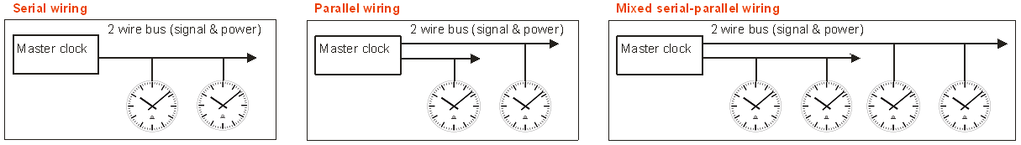

As an alternative, the clock can also be manufactured to be powered through mains power supply (240 VAC).

**ORDER REFERENCE:**

**ML** **. *1 . 2 . 3. 4. 5. 6. 7.*** (see position description below)

1. **type of back-light illumination**
   1. without: **0**
   2. LED: **2**
2. **dial diameter size**
   1. 50 cm: **50**
   2. 60 cm: **60**
   3. 80 cm: **80**
3. **housing :**
   1. single face: **R1**
   2. double face: **R2**
4. **synchronization and hands specification:**
   1. Mobaline hour and minute hands: **M16**
   2. Mobaline hour, minute and second hands: **M18**
   3. Mobaline hour and minute hands (230 VAC): **C01**
   4. Mobaline hour, minute and second hands (230 VAC): **C03**
5. **numeral type**
   1. markers only: **300**
   2. markers and numbers: **315**

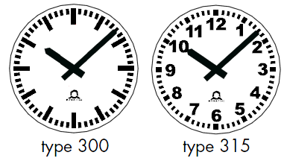 

**Type 300 Type 315 Type 120**

1. **cover glass** 
   1. Arced Plexiglas HPT: **1**
2. **mounting type:**
   1. direct wall mounting (single face): **00**
   2. wall mounting (double face): **10**
   3. ceiling mounting: **20**
   4. ceiling bracket (rod length of 50 cm): **21**
   5. ceiling bracket (rod length of 60 cm): **22**
   6. ceiling bracket (rod length of 80 cm): **23**
   7. pole mounting:  **30**
   8. socket mounting:  **50**

**METROLINE (outdoor analog clock) for NTP**

Hint: Refer to leaflet for more detailed information.

Additional parts and options:

MOBA-NMS: configuration, management and supervision software

The outdoor analog **METROLINE** slave clock, with hour & minute black hands and optional red second hand, is available in single or double face execution with a large selection of suspension as: wall, ceiling, socket or pole- mounting.

This is a round style weather-proof clock, with housing made of high quality white powder coated aluminium, fitted with convex acryl front glass protective cover. The clock is available in dial’s diameters of 50, 60 and 80 cm with markers printed in black and optionally black numerals for hours. The clock is available with optional dial back-light illumination made by LED.

NTP- synchronised movement with 10/100 Mbit/s baseT (RJ45 Ethernet):

The clock embeds a microprocessor based movement performing communication analysis and diagnostics as well as the mechanical check of hand's position.

The movement synchronised by NTP protocol is able to sustain unicast (with up to 4 NTP referenced servers) and multicast communication modes. In addition it has the capability to decode NTP frame containing time zones information in order to be used for world time clock realisation.

The configuration, management and supervision of more than 1000 movements can be done through network remote access by MOBA-NMS software which provides a user friendly graphic interface under windows environment.

The movement configuration can also be fully and autonomously achieved by DHCP protocol under server management. The movement supports also the SNMP protocol and is able to manage alarm and alive messages straps.

Powering is performed by PoE (power over Ethernet) via standard RJ-45 Ethernet interface or by low voltage 24 VDC via a dedicated connector. The clock can also be powered through mains power supply (100 - 230 VAC, 50 – 60 Hz) with optional built-in add-on converter.

**ORDER REFERENCE:**

**ML . *1 . 2 . 3. 4. 5. 6. 7.*** (see position description below)

1. **type of back-light illumination**
   1. without: **0**
   2. LED: **2**
2. **dial diameter size**
   1. 50 cm: **50**
   2. 60 cm: **60**
   3. 80 cm: **80**
3. **housing :**
   1. single face: **R1**
   2. double face: **R2**
4. **synchronization and hands specification:**
   1. Ethernet – NTP/ power - PoE / hour and minute hands: **N11**
   2. Ethernet – NTP/ power - PoE / hour, minute and second hands: **N13**
   3. Ethernet – NTP/ power-230VAC / hour and minute hands: **N01**
   4. Ethernet – NTP/ power-230VAC / hour, minute and second hands: **N03**
   5. NCC: Ethernet – NTP/ power- PoE or 230VAC / hour and minute hands: **C09**
   6. NCC: Ethernet – NTP/ power- PoE or 230VAC / hour, minute and sec. hands: **C11**
5. **numeral type**
   1. markers only: **300**
   2. markers and numbers: **315**
   3. Special dial: **120**



**Type 300 Type 315 Type 120**

1. **cover glass** 
   1. Arced Plexiglas HPT: **1**
2. **mounting type:**
   1. direct wall mounting (single face): **00**
   2. wall mounting (double face): **10**
   3. ceiling mounting: **20**
   4. ceiling bracket (rod length of 50 cm): **21**
   5. ceiling bracket (rod length of 60 cm): **22**
   6. ceiling bracket (rod length of 80 cm): **23**
   7. pole mounting:  **30**
   8. socket mounting:  **50**

**METROLINE (outdoor analog clock) for Wireless**

Hint: Refer to leaflet for more detailed information.

Additional parts and options:

WTD 868-T: Wireless Time Distribution Transmitter

WTD 868-T MPS: external power supply for WTD transmitter

WTD 868-RS: Wireless Time Distribution Test Receiver

WTD Repeater: Wireless Time Distribution Repeater

The outdoor analog **METROLINE** slave clock, with hour & minute black hands and optional red second hand, is available in single or double face execution with a large selection of suspension as: wall, ceiling, socket or pole- mounting.

This is a round style weather-proof clock, with housing made of high quality white powder coated aluminium, fitted with convex acryl front glass protective cover. The clock is available in dial’s diameters of 50, 60 and 80 cm with markers printed in black and optionally black numerals for hours. The clock is available with optional dial back-light illumination made by LED or long life Neon.

Movement with Wireless receiver (WTD):

The movement is synchronised by a wireless protocol modulated in the 868 MHz frequency band in accordance with AFNOR NFS code 87500. In addition it has the capability to decode time zones protocol’s information in order to be used for world time clock realisation.

The movement embedded microprocessor performs communication analysis and diagnostics as well as the mechanical check of hand's position.

The movements can be powered by Lithium battery or through mains power supply (110 -240 VAC) with optional built-in add-on converter.

**ORDER REFERENCE:**

**ML . *1 . 2 . 3. 4. 5. 6. 7.*** (see position description below)

1. **type of back-light illumination**
   1. without: **0**
   2. fluorescent tube: **1**
   3. LED: **2**
2. **dial diameter size**
   1. 50 cm: **50**
   2. 60 cm: **60**
   3. 80 cm: **80**
3. **housing :**
   1. single face: **R1**
   2. double face: **R2**
4. **synchronization and hands specification:**
   1. Wireless / power by Lithium battery / hour and minute hands: **R80**
   2. Wireless / power by 230 VAC / hours and minute hands: **R82**
   3. Wireless / power by 230 VAC / hours, minute and second hands: **R84**
5. **numeral type**
   1. markers only: **300**
   2. markers and numbers: **315**

 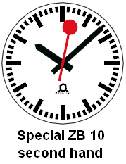

1. **cover glass** 
   1. internal reference: **1**
2. **mounting type:**
   1. direct wall mounting (single face): **00**
   2. wall mounting (double face): **10**
   3. ceiling mounting: **20**
   4. ceiling bracket (rod length of 50 cm): **21**
   5. ceiling bracket (rod length of 60 cm): **22**
   6. ceiling bracket (rod length of 80 cm): **23**
   7. pole mounting:  **30**
   8. socket mounting:  **50**