**PROFILINE (outdoor analog clock) for MOBALINE**

Hint: Refer to leaflet for more detailed information.

Additional parts and options:

The outdoor analog **PROFILINE** slave clock, with hour & minute black hands and optional red second hand, is available in single or double face execution with a large selection of suspension as: wall, ceiling or pole- mounting.

This is a round style weather-proof clock, with housing made of high quality anodized aluminium, fitted with convex acryl front glass protective cover. The clock is available in dial’s diameters of 50, 60 and 80 cm with markers printed in black and optionally black numerals for hours. The clock is available with optional dial back-light illumination made by LED.

Movement with MOBA*Line* interface:

The movement is synchronised and powered by MOBALine low voltage, noise immune modulated protocol over a simple 2-wires cable. The movement embedded microprocessor performs protocol analysis and diagnostics as well as the mechanical check of hand's position. In addition it has the capability to decode time zones protocol’s information in order to be used for world time clock realisation.

The MOBALine bus allows versatile installation topology, clocks can be wired in serial, parallel or mixed serial-parallel configuration. Every single branch, starting from the master clock, can be up to 1600 meters long.

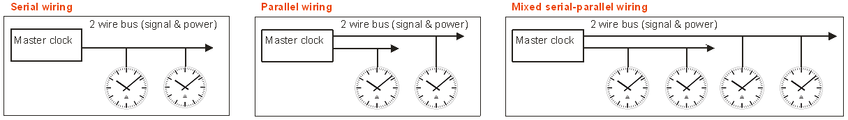

As an alternative, the clock can also be manufactured to be powered through mains power supply (100 -230 VAC, 50 – 60 Hz).

**ORDER REFERENCE:**

**PL** **. *1 . 2 . 3. 4. 5. 6. 7.*** (see position description below)

1. **type of back-light illumination**
   1. without: **0**
   2. LED: **2**
2. **dial diameter size**
   1. 50 cm: **50**
   2. 60 cm: **60**
   3. 80 cm: **80**
3. **housing :**
   1. single face: **R1**
   2. double face: **R2**
4. **synchronization and hands specification:**
   1. MOBALine hour and minute hands: **M16**
   2. MOBALine hour, minute and second hands: **M18**
   3. MOBALine hour and minute hands (230 VAC): **C01**
   4. MOBALine hour, minute and second hands (230 VAC): **C03**
5. **numeral type**
   1. markers only: **300**
   2. markers and numbers: **315**
   3. Special dial: **120**

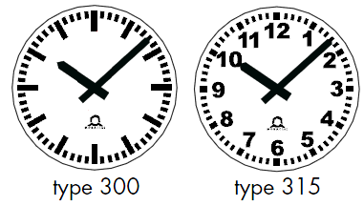 

**Type 300 Type 315 Type 120**

1. **cover glass** 
   1. Mineral glass: **1**
   2. Ball-throw resistant: **2**
   3. Polycarbonat: 3
2. **mounting type:**
   1. direct wall mounting (single face): **00**
   2. wall mounting (WA) (double face): **10**
   3. ceiling suspension (DA): **20**
   4. Lateral pole mounting (SM): **30**
   5. Central pole (ZM):  **40**

**PROFILINE (outdoor analog clock) for NTP**

Hint: Refer to leaflet for more detailed information.

Additional parts and options:

MOBA-NMS: configuration, management and supervision software

The outdoor analog **PROFILINE** slave clock, with hour & minute black hands and optional red second hand, is available in single or double face execution with a large selection of suspension as: wall, ceiling or pole- mounting.

This is a round style weather-proof clock, with housing made of high quality white powder coated aluminium, fitted with convex acryl front glass protective cover. The clock is available in dial’s diameters of 50, 60 and 80 cm with markers printed in black and optionally black numerals for hours. The clock is available with optional dial back-light illumination made by LED.

NTP- synchronised movement with 10/100 Mbit/s baseT (RJ45 Ethernet):

The clock embeds a microprocessor based movement performing communication analysis and diagnostics as well as the mechanical check of hand's position.

The movement synchronised by NTP protocol is able to sustain unicast (with up to 4 NTP referenced servers) and multicast communication modes. In addition it has the capability to decode NTP frame containing time zones information in order to be used for world time clock realisation.

The configuration, management and supervision of more than 1000 movements can be done through network remote access by MOBA-NMS software which provides a user friendly graphic interface under windows environment.

The movement configuration can also be fully and autonomously achieved by DHCP protocol under server management. The movement supports also the SNMP protocol and is able to manage alarm and alive messages straps.

Powering is performed by PoE (power over Ethernet) via standard RJ-45 Ethernet interface or by low voltage 24 VDC via a dedicated connector. The clock can also be powered through mains power supply (100 - 230 VAC, 50 – 60 Hz) with optional built-in add-on converter.

**ORDER REFERENCE:**

**PL . *1 . 2 . 3. 4. 5. 6. 7.*** (see position description below)

1. **type of back-light illumination**
   1. without: **0**
   2. LED: **2**
2. **dial diameter size**
   1. 50 cm: **50**
   2. 60 cm: **60**
   3. 80 cm: **80**
3. **housing :**
   1. single face: **R1**
   2. double face: **R2**
4. **synchronization and hands specification:**
   1. Ethernet – NTP/ power - PoE / hour and minute hands: **N11**
   2. Ethernet – NTP/ power - PoE / hour, minute and second hands: **N13**
   3. Ethernet – NTP/ power-230VAC / hour and minute hands: **N01**
   4. Ethernet – NTP/ power-230VAC / hour, minute and second hands: **N03**
   5. NCC: Ethernet – NTP/ power- PoE or 230VAC / hour and minute hands: **C09**
   6. NCC: Ethernet – NTP/ power- PoE or 230VAC / hour, minute and sec. hands: **C11**
5. **numeral type**
   1. markers only: **300**
   2. markers and numbers: **315**
   3. Special dial: **120**



**Type 300 Type 315 Type 120**

1. **cover glass** 
   1. Mineral glass: **1**
   2. Ball-throw resistant: **2**
   3. Polycarbonat: 3
2. **mounting type:**
   1. direct wall mounting (single face): **00**
   2. wall mounting (WA) (double face): **10**
   3. ceiling suspension (DA): **20**
   4. Lateral pole mounting (SM): **30**
   5. Central pole (ZM):  **40**