TREND (indoor analog clock) for MOBALINE

Hint: Refer to leaflet for more detailed information.

Additional parts and options:
TR.30.WS: wall and ceiling kit for 30cm double face clock
TR.40.WS: wall and ceiling kit for 40cm or double face clock

The indoor analog TREND slave clock, with hour & minute black hands and optional red second hand, is available in single or double face execution.
This is a round style clock, with a low-profile housing made of high quality white ABS plastic or metal, fitted with a transparent mineral glass protective cover. The clock is available in dial’s diameters (effective diameter of the dial) of 30, and 40 cm with markers printed in black and optionally black numerals for hours. The housing is available in several colors (specific RAL painting on request).

Movement with MOBALine interface:
The movement is synchronised and powered by Mobaline low voltage, noise immune modulated protocol over a simple 2-wires cable. The movement embedded microprocessor performs protocol analysis and diagnostics as well as the mechanical check of hand's position. In addition it has the capability to decode time zones protocol’s information in order to be used for world time clock realisation.
The Mobaline bus allows versatile installation topology, clocks can be wired in serial, parallel or mixed serial-parallel configuration. Every single branch, starting from the master clock, can be up to 1600 meters long.

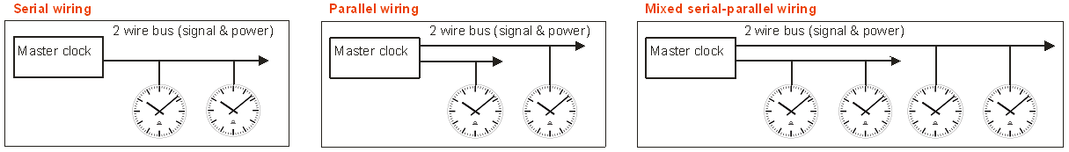

ORDER REFERENCE:

TR . 1 . 2 . 3. 4. 5. 6. 7. (see position description below)

- type of back-light illumination
  - without: 0

- dial diameter size
  - 30 cm: 30
  - 40 cm: 40

- housing:
  - round single face: R1
  - double sided R2

- synchronization and hands specification:
  - Mobaline hour and minute hands: M40
  - Mobaline hour, minute and second hands M41

- numeral type
  - markers only (bold): 200
  - markers and numbers (bold): 210
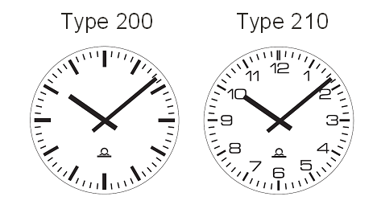

- cover glass
  - mineral glass: 0
  - Plexiglass resist 3

- housing options:
  - plastic white (RAL9002): P0
  - plastic anthracite (RAL7016): P1
  - metal white (RAL9002): M0
  - metal anthracite (RAL7016): M1
  - metal chrom steel: M2

TREND (indoor analog clock) for NTP

Hint: Refer to leaflet for more detailed information.

Additional parts and options:
TR.30.WS: wall and ceiling kit for 30cm double face clock
TR.40.WS: wall and ceiling kit for 40cm or double face clock
MOBA-NMS: configuration, management and supervision software

The indoor analog TREND slave clock, with hour & minute black hands and optional red second hand, is available in single or double face execution. Also for the double-sided version only one LAN cable is required.
This is a round style clock, with a low-profile housing made of high quality white ABS plastic or metal, fitted with a transparent mineral glass protective cover. The clock is available in dial’s diameters (effective diameter of the dial) of 30, and 40 cm with markers printed in black and optionally black numerals for hours. The housing is available in several colors (specific RAL painting on request).

NTP- synchronised movement with 10/100 Mbit/s (baseT-8P8C) Ethernet interface:
The clock embeds a microprocessor based movement performing communication analysis and diagnostics as well as the mechanical check of hand's position.
The movement synchronised by NTP protocol is able to sustain unicast (with up to 4 NTP referenced servers) and multicast communication modes. In addition it has the capability to decode NTP frame containing time zones information in order to be used for world time clock realisation.
The configuration, management and supervision of more than 1000 movements can be done through network remote access by MOBA-NMS software which provides a friendly user graphic interface under windows environment.
The movement configuration can also be fully and autonomously achieved by DHCP protocol under server management. The movement supports also the SNMP protocol and is able to manage alarm and alive messages straps.
Powering is performed by PoE (power over Ethernet) via standard RJ-45 Ethernet interface.

ORDER REFERENCE:

TR . 1 . 2 . 3. 4. 5. 6. 7. (see position description below)

- type of back-light illumination
  - without: 0

- dial diameter size
  - 30 cm: 30
  - 40 cm: 40

- housing:
  - round single face: R1
  - double sided R2

- synchronization and hands specification:
  - NTP hour and minute hands: N40
  - NTP hour, minute and second hands N41

  - numeral typemarkers only (bold): 200
  - markers and numbers (bold): 210

- cover glass
  - mineral glass: 0
  - Plexiglass resist 3

- housing options:
  - plastic white (RAL9002): P0
  - plastic anthracite (RAL7016): P1
  - metal white (RAL9002): M0
  - metal anthracite (RAL7016): M1
  - metal chrom steel: M2

